**ASSIGNMENT 3**

**Name : T.vamsi krishna**

**Regno:192224122**

**Course code: DSA0163**

**Course name:Object Oriented C++**

**SINGLE INHERITANCE**

#include <iostream>

using namespace std;

class initial

{

public:

int x;

void read()

{

cout<<"Enter the value of x";

cin>>x;

}

void display()

{

cout<<"X = "<<x<<"\n";

}

};

class final : public initial

{

public:

int y;

void read1()

{

cout<<"Enter the value of y";

cin>>y;

}

void display1()

{

cout<<"Z = X * Y "<<x*y<<"\n";

}

};

int main()

{

final F;

F.read();

F.read1();

F.display1();

return 0;

}

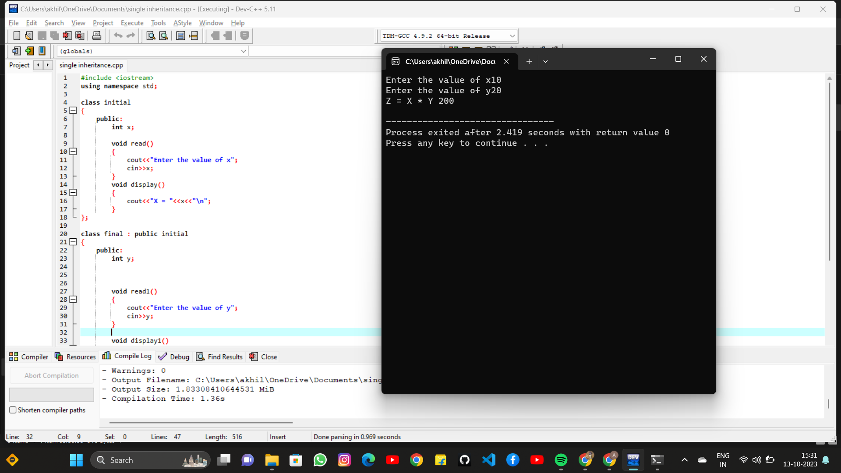

**MULTI-LEVEL INHERITANCE**

#include <iostream>

using namespace std;

class initial

{

public:

int x;

void read()

{

cout<<"Enter the value of x \n";

cin>>x;

}

void display()

{

cout<<"X ="<<x<<"\n";

}

};

class middle : public initial

{

public:

int y;

void read1()

{

cout<<"Enter the value of y\n";

cin>>y;

}

void display1()

{

cout<<"Y ="<<y<<"\n";

}

};

class final : public middle

{

public:

int z;

void read2()

{

cout<<"Enter the value of z\n";

cin>>z;

}

void display2()

{

cout<<x+y+z;

}

};

int main()

{

final F;

F.read();

F.read1();

F.read2();

F.display2();

}

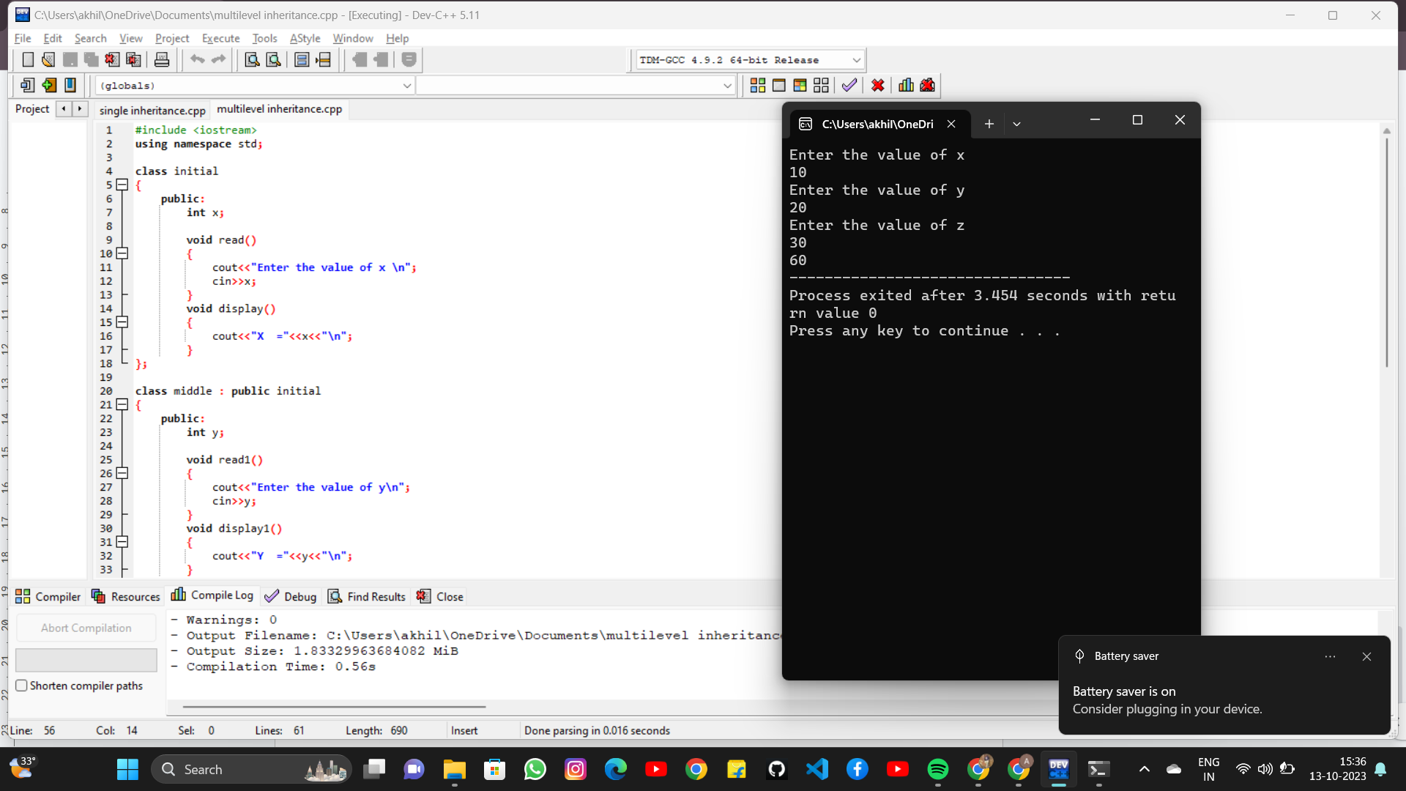

**MULTIPLE INHERITANCE**

#include <iostream>

using namespace std;

class initial

{

public:

int x;

void read()

{

cout<<"Enter the value of X";

cin>>x;

}

void display()

{

cout<<"X ="<<x<<"\n";

}

};

class middle

{

public:

int y;

void read1()

{

cout<<"Enter the value of y";

cin>>y;

}

void display1()

{

cout<<"Y ="<<y<<"\n";

}

};

class final : public initial , public middle

{

public:

int z;

void read2()

{

cout<<"Enter the value of Z";

cin>>z;

}

void display2()

{

cout<<"Multiplication: "<<x*y*z<<"\n";

}

};

int main()

{

final F;

F.read();

F.read1();

F.read2();

F.display2();

}

